**Multi-Sectoral Needs Assessment Survey**

**Location:** Rann, Kala Balge LGA, Borno State

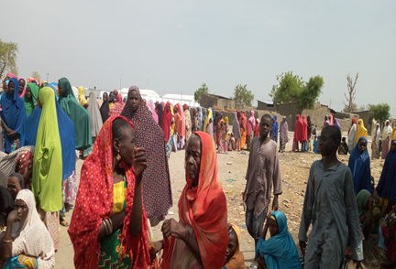

*Rann residents queued up for a TdH soap distribution. Source: TdH Nigeria, (May, 2019)*

**TdH NIGERIA MAIDUGURI**

*30/11/2019*

Analysis and Report by **Henry Akuete – MEAL Technical Supervisor**

Technical Support by **John Sughnen Wanshe (Data Analyst)**

**Table of Contents**

Contents

Abstract 3

Context 4

Objectives 4

Location 4

Methodology 5

Sampling 5

Duration 6

Maps 6

Results 7

Demographics 7

Shelter 8

WASH 11

Water Access 11

Hygiene Promotion 14

Access to Sanitation facilities 16

Child Protection 18

Protection 26

Education 28

FSL 30

Health 33

Humanitarian Service needs 37

Summary and Conclusion 38

APPENDIX 41

# Abstract

Rann is a town Kala Balge LGA of Borno State, Nigeria. The town accommodates about 75, 000 IDPs displaced as a result of the Boko Haram/ISWAP insurgency since 2010[1]. Rann is one of the localities in north-eastern Nigeria that have become accessible to humanitarian organizations. Emergency assistance is gradually being increased in areas that were previously unreachable. In Rann, IDPs struggle with serious food shortages and severe acute malnutrition. Humanitarian access to the area has been difficult due to insecurity and bad roads, as stated by United Nations Office for the Coordination of Humanitarian Affairs in its press release. On 17 January 2017, the Nigerian Air Force mistakenly bombed the camp, leaving at least 52 people dead and over 100 injured[2].

On 14 January 2019, Rann was overrun by insurgents amid a general increase of insurgent attacks in the area, and destroyed, with many inhabitants fleeing across the border to Bodo in Cameroon. Though the Nigerian military and allied Cameroonian Armed Forces forces subsequently retook Rann, they later abandoned it, so that Boko Haram launched another raid against the town on 28 January 2019. The militants again set the settlement ablaze, murdered local elders, and caused tens of thousands to flee.This time, the refugees from Rann relocated to Goura in Cameroon. However the IDPs have mostly returned to the town with the return of security forces[3]. TdH was previously implementing WaSH and Health projects in Rann funded by the Nigerian Humanitarian Fund (NHF). In lieu of this and the tentative ECHO 2020 grant, TdH is carried out a multi-sectoral needs assessment focusing on Child Protection, Health and WASH to aid a focused situational analysis pursuant to a humanitarian intervention. The results are presented in this report and summarily, the top 3 service needs identified by HH are:

1. Food assistance
2. Education support
3. Health support

# Context

Rann is a town Kala Balge LGA of Borno State, Nigeria. The town accommodates about 75, 000 IDPs displaced as a result of the Boko Haram/ISWAP insurgency since 2010[4]. Rann is one of the localities in north-eastern Nigeria that have become accessible to humanitarian organizations. Emergency assistance is gradually being increased in areas that were previously unreachable. In Rann, IDPs struggle with serious food shortages and severe acute malnutrition. Humanitarian access to the area has been difficult due to insecurity and bad roads, as stated by United Nations Office for the Coordination of Humanitarian Affairs in its press release. On 17 January 2017, the Nigerian Air Force mistakenly bombed the camp, leaving at least 52 people dead and over 100 injured[5].

On 14 January 2019, Rann was overrun by insurgents amid a general increase of insurgent attacks in the area, and destroyed, with many inhabitants fleeing across the border to Bodo in Cameroon. Though the Nigerian military and allied Cameroonian Armed Forces forces subsequently retook Rann, they later abandoned it, so that Boko Haram launched another raid against the town on 28 January 2019. The militants again set the settlement ablaze, murdered local elders, and caused tens of thousands to flee.This time, the refugees from Rann relocated to Goura in Cameroon. However the IDPs have mostly returned to the town with the return of security forces[6]. TdH was previously implementing WaSH and Health projects in Rann funded by the Nigerian Humanitarian Fund (NHF). In lieu of this and the tentative ECHO 2020 grant, TdH is carried out a multi-sectoral needs assessment focusing on Child Protection, Health and WASH to aid a focused situational analysis pursuant to a humanitarian intervention.

## Objectives

The main objectives of the needs assessment was to determine the contextual profile and KAP of the target population of Rann as per Child protection, Health and WASH, FSL needs and endemic service gaps. This would be invaluable in justifying and fine-tuning an effective and efficient humanitarian relief intervention based on the ECHO 2020 grant.

## Location

The assessment was carried out in Rann town, Kala Balge LGA of Borno state, Nigeria.

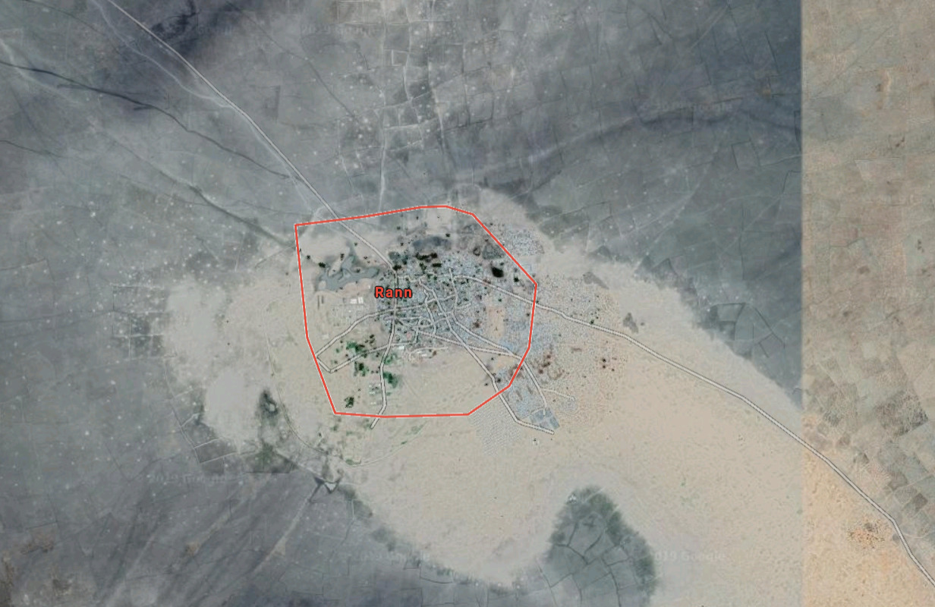

*Fig. 1. Aerial Map showing of Rann*

## Methodology

A standardized quantitative survey questionnaire (in Appendix) was used in order to acquire a more in-depth and comprehensive statistically backed data on needs and KAP concerning the aforementioned sectors at the household level, and data was collected via KoboCollect (an android based mobile data collection application of Kobotoolbox). Questionnaires obtained data on demographic and socio-economic characteristics, contextual needs, knowledge, attitudes, and practices regarding child protection, WASH and health. Observations were also made by interview teams.

## Sampling

The estimated population of Ngala town is about 75,000 individuals and based on the estimated HH size of 6 persons per HH, the estimated number of HHs in Ngala is about **12,500 HHs**[7]. The estimated representative sample size for the population of 75,000 HHs is 373 HHs. The required sample size of **373 households** was calculated using the sample size calculator application domiciled on https://www.surveysystem.com/sscalc.htm , based on the estimated HH population of **12,500**, a confidence level of 95% and a confidence interval of 5. Therefore, in order to obtain a statistically representative sample of the HH population of Rann, two-stage sampling was used. In the first stage, all HHs were divided into 5 geo-spatial clusters with even number of HHs per cluster. In the second stage the total required sample size of HHs (382) was divided by the number of clusters and the result is the number of HHs that were selected from each cluster for surveying via simple random sampling. A breakdown of the final number of HHs sampled per site or cluster is presented in the table below. It should be noted that although the initial target sample size was 373 HHs, the final number of HHs surveyed (by a team of 20 enumerators—1 female and 1 male per team) were 405 HHs.

|  |  |
| --- | --- |
| **Sites/Clusters** | **Number of HHs surveyed** |
| Ajari | 82 |
| Boarding Primary school | 65 |
| Bulamari | 47 |
| General Hospital | 94 |
| Kelaguru | 117 |
|  | **405** |

## Duration

The survey was carried out for 5 days from 18th November 2019 to 22nd November 2019.

## Maps

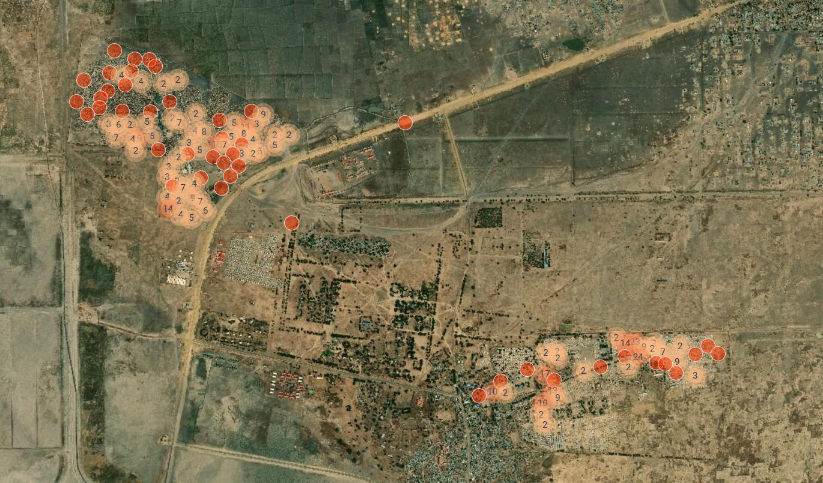

*Fig.2. Aerial Map of Rann showing the locations surveyed.*

# Results

## Demographics

The average population of individuals per HH in Rann is 8. It is important to note that 70% of HHs in Rann are IDPs while 15% are returnees and 14% are non-displaced/host community HHs.

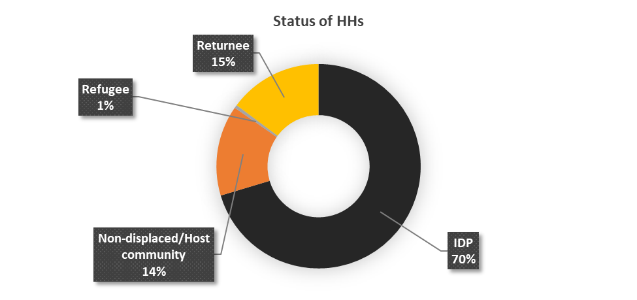

63% of HHs in Rann speak shuwa while 25% peak Kanuri, 5% speak Arabic and 2% speak Fulfude as a primary language.

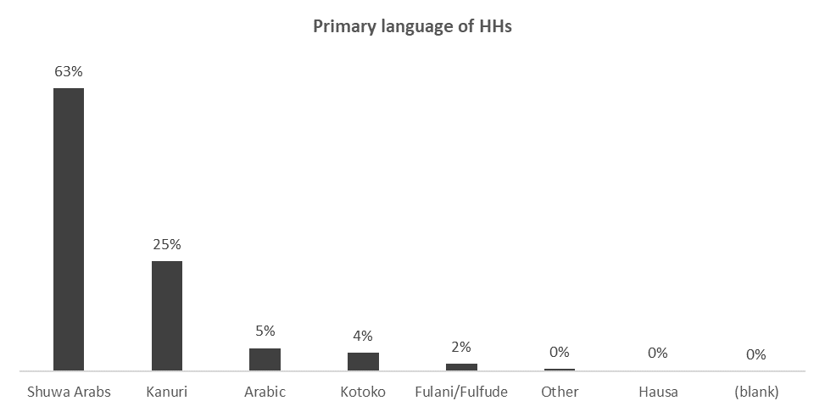

24% of HHs are women headed households.

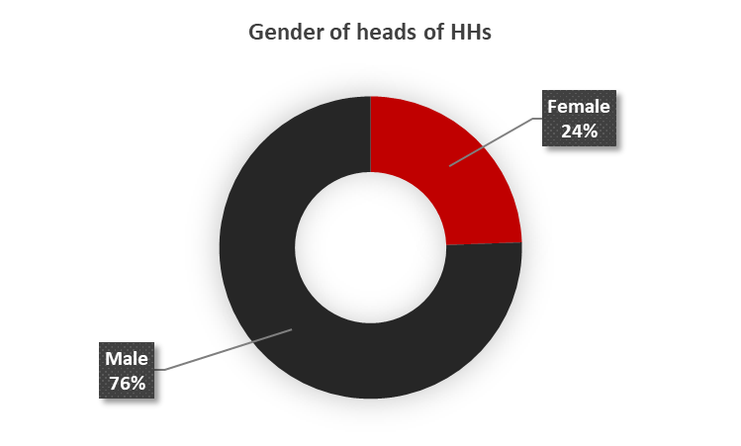

55% of HHs in Rann are currently hosting other people who are not family members and sharing their resources with them. These HHs are hosting an average of 3 such persons per HH. There is an average of 1 unaccompanied child per HH in Rann

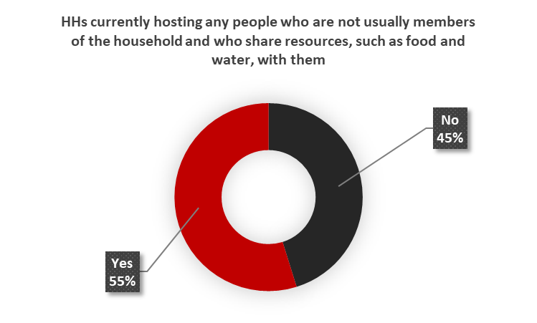

# Shelter

71% of HHs are residing in permanent shelters while 24% reside in makeshift shelters. It is pertinent to note that 4% of HHs resisde in rented accomomodation.

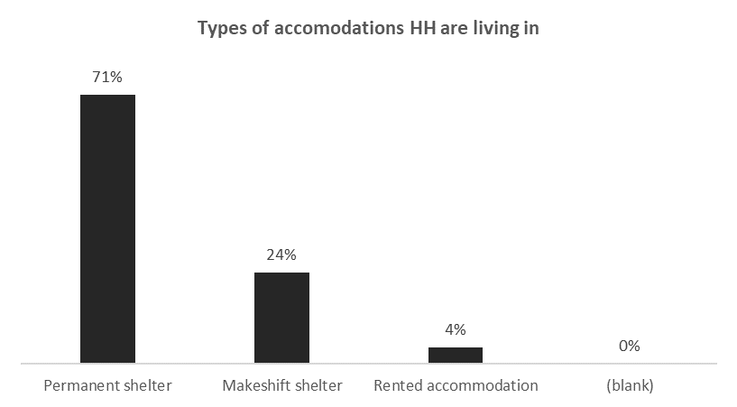

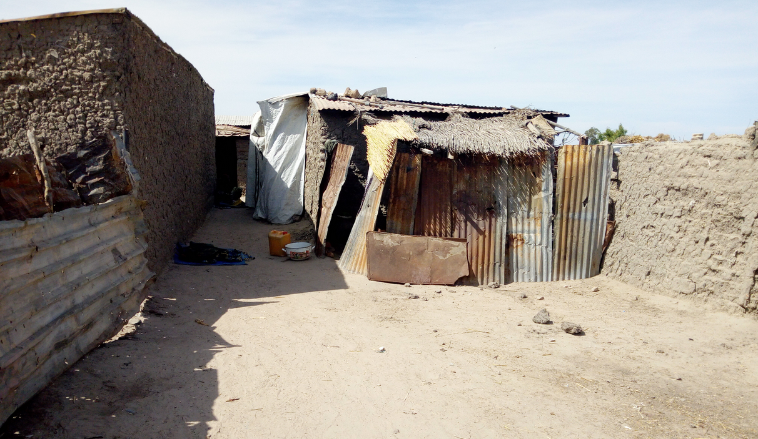

*Fig.3. Type of permanent shelter constructed by a HH in Rann*

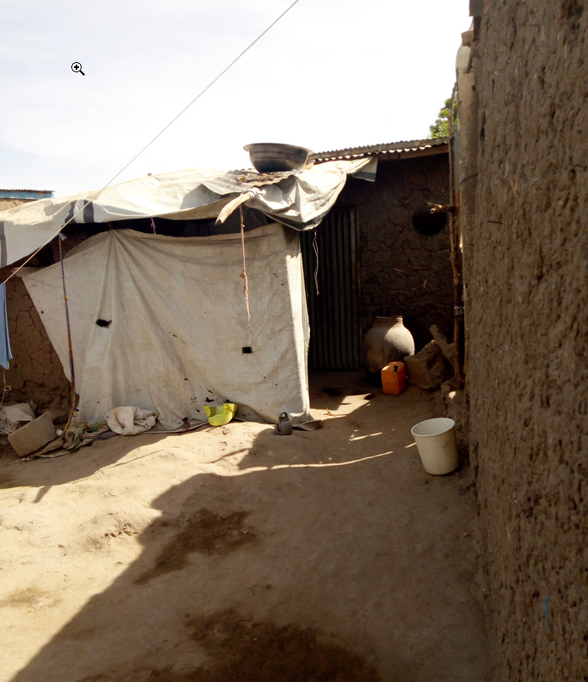

*Fig.4. Type of permanent shelter constructed by a HH in Rann*

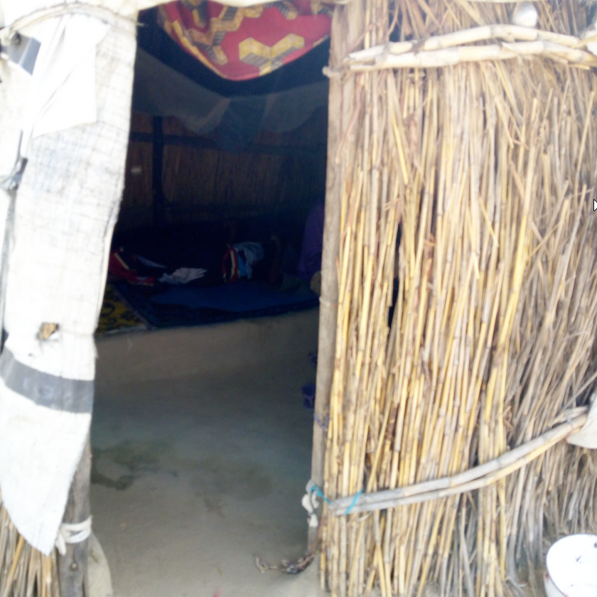

*Fig.5. Type of traditional makeshift shelter constructed by a HHs in Rann*

42% of the shelters are in an average condition (fulfilling the objectives but not overly satisfied/can be better), while 35% are in a poor state (not meeting all the needs and definitely needs improvement). 23% of the HHs are in a good state (meets all the needs).

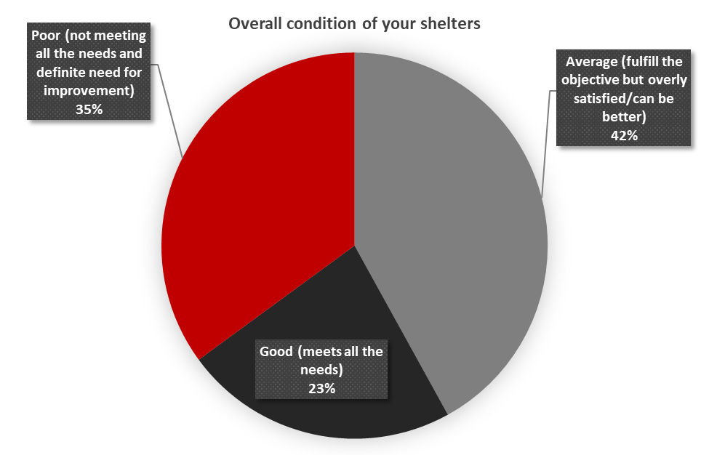

# WASH

## Water Access

58% of HHs get their water from a tap connected to a borehole. 21% of HHs get water from a tap connected to a water tank which is usually filled by a truck (not connected to a water source). 6% of HHs get water from commercial water sellers (Mai ruwa).

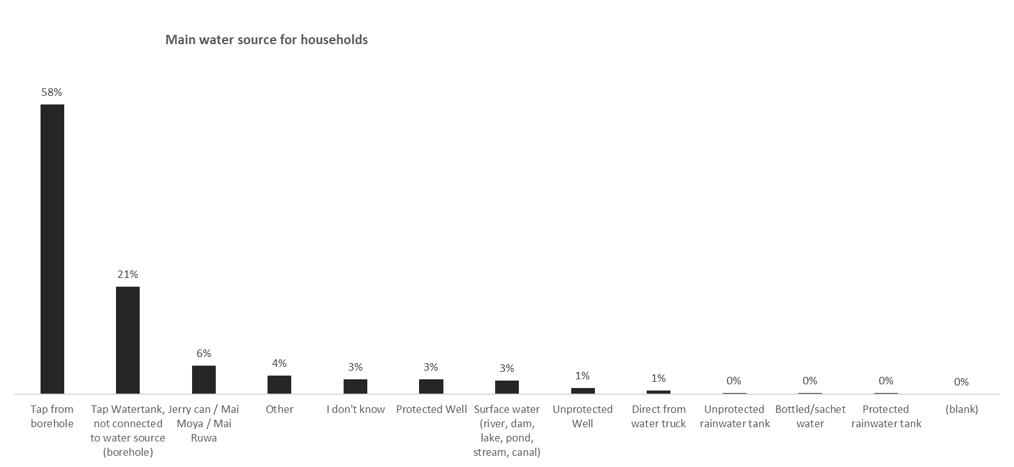

Most HHs said their water sources are still available during the dry season. However, 7% of HHs said their water sources are NOT available during the dry season.

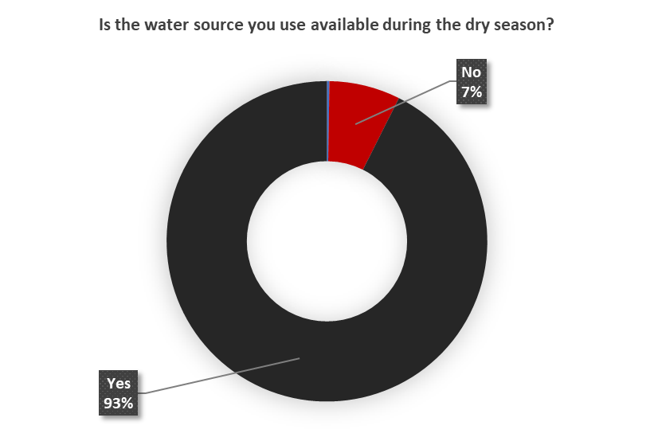

93% of HHs said they have enough water to meet their HH needs. However, 6% of HHs said they do not get enough water to meet their HH needs.

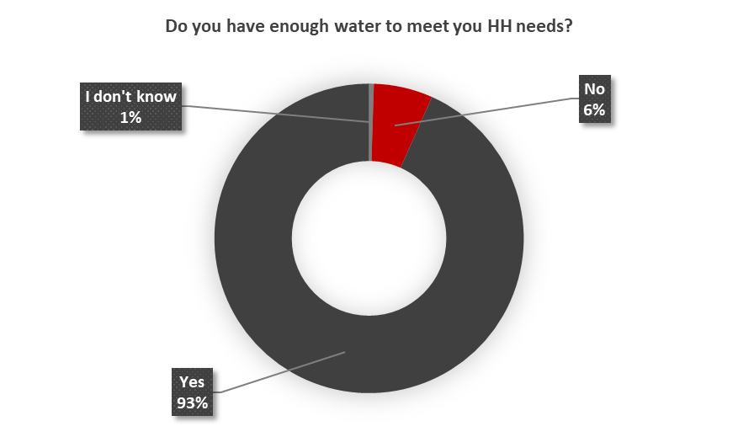

90% of HHs do not pay for water. However, 9% of HHs said they pay for water.

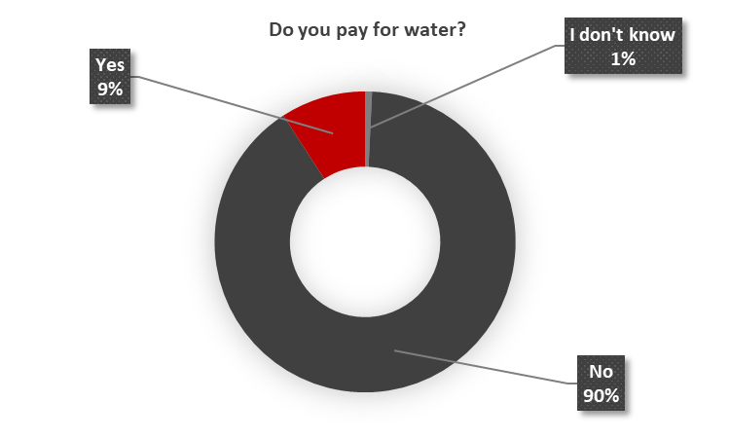

49% of HHs said it takes 5 mins or less to get water and 37% of HHs take more than 5 mins to 10 mins to get water. It is however important to observe that 4% of HHs take more than 30 minutes to walk to the water point.

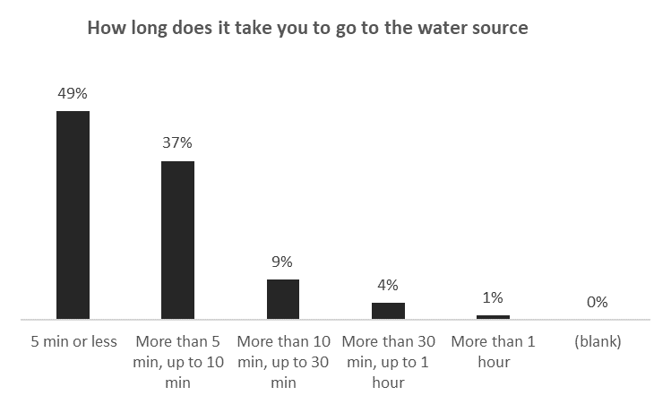

47% of HHs in Rann spend more than 30 mins up to 2 hours at the water points on the waiting queues before they fetch water.

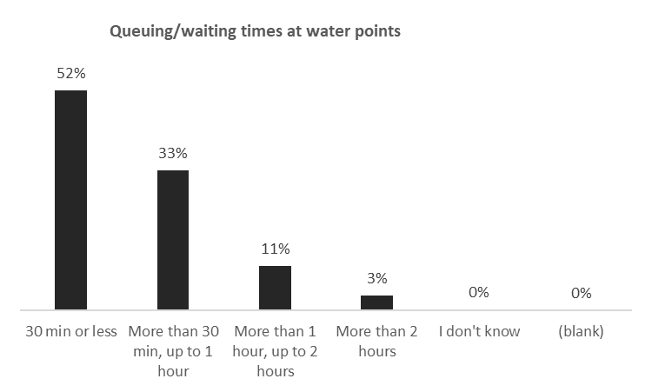

The average number of times HHs collect water per day in Rann is 3.

HHs have an average of 3 water containers per HH for water collection.

The average TOTAL volume of ALL the water containers used per HH to collect water is 41 liters.

Therefore, the average water collected per HH per day is 123 liters and based on the average HH size of 8 persons per HH, **the average water collected per person per day is 15 liters**.

28% of HHs in Rann do not have a water storage container.

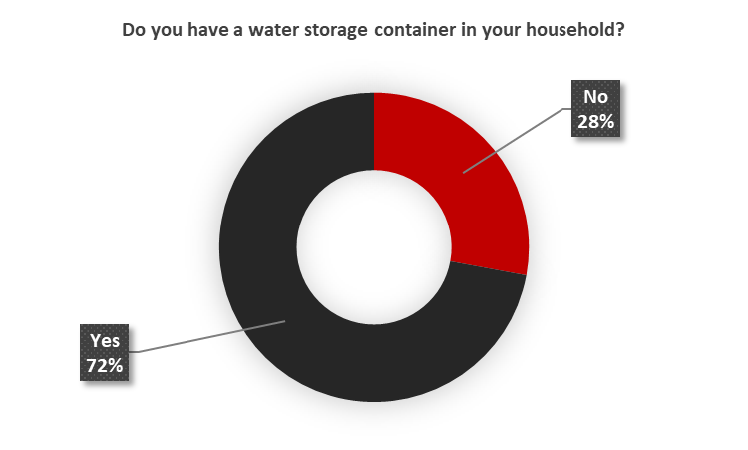

HHs have an average of 2 water storage containers per HH.

The average TOTAL volume of ALL the water storage containers used per HH is 73 liters.

Therefore, **the average water storage capacity per person per day per HH is 9 liters**.

It is pertinent to note that **52% of HHs have less than 10 liters per person per day water storage capacity**.

## Hygiene Promotion

25% of HHs did not receive any NFI kits during displacement

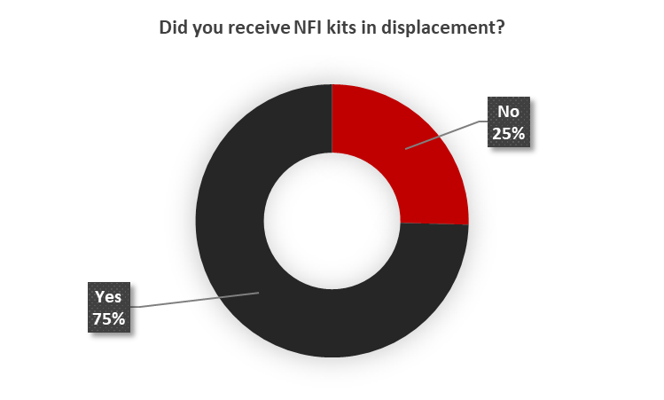

An elucidation of the types of items received by the 75% of HHs that said they received NFI kits is presented in the chart below.

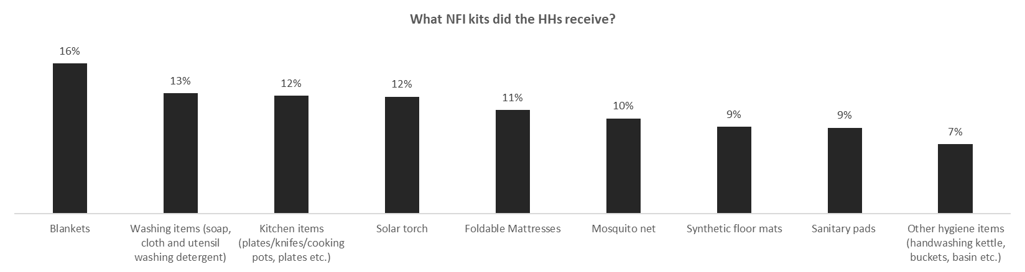

An elucidation of the type of items HHs said they will need in the upcoming 3 months is presented in the chart below.

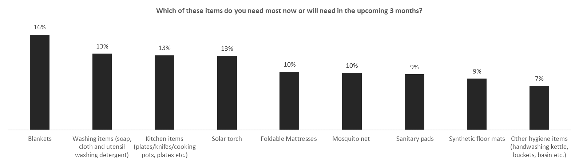

**18% of HHs DO NOT treat their water before drinking.** The reasons given by HHs for not treating their water before drinking ranges from lack of materials for water purification/treatment, lack of time, to "no need as the water I collect has been treated".

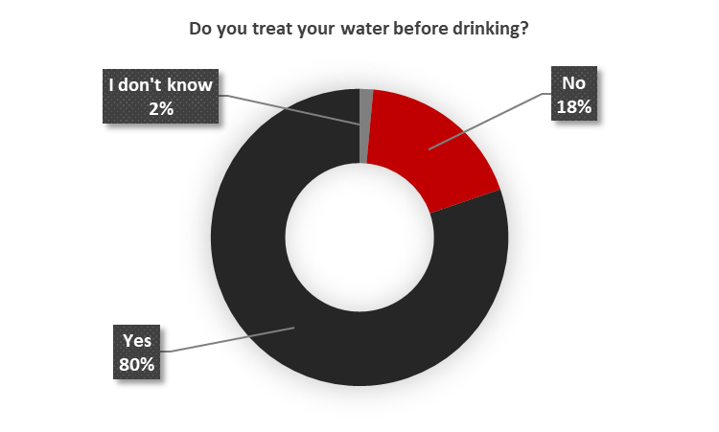

19% of HHs do not have soap.

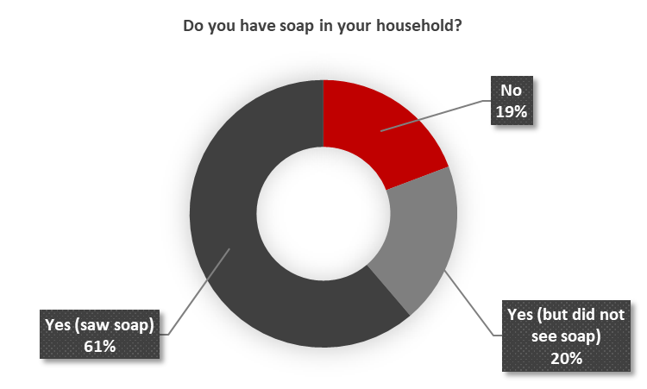

**7% of HHs know less than 3 critical times they should wash their hands in a day.**

7% of HHs DO NOT clean their water containers**.**

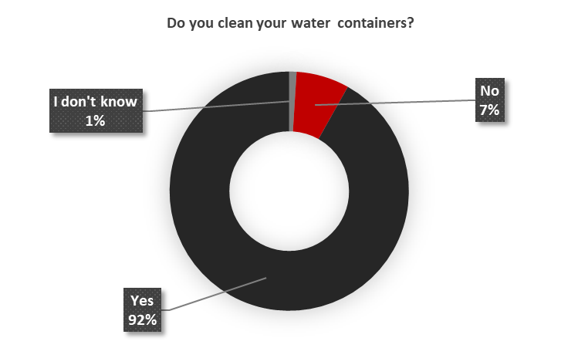

39% of HHs in Rann DO NOT have a hand washing device in their HH. 30% of HHs have not attended any hygiene promotion session in the last 1 month.

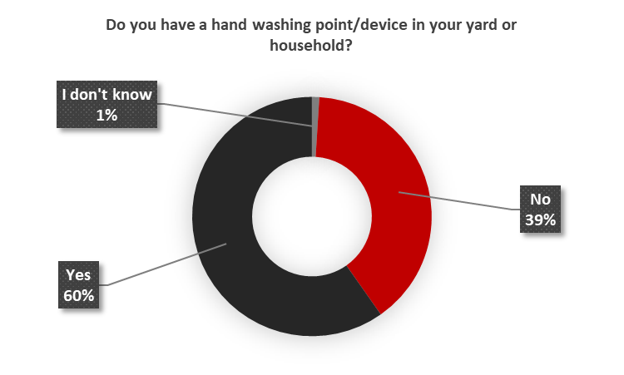

## Access to Sanitation facilities

26% of HHs do not have a latrine nearby. This implies that 26% of HHs DO NOT have access to a latrine facility.

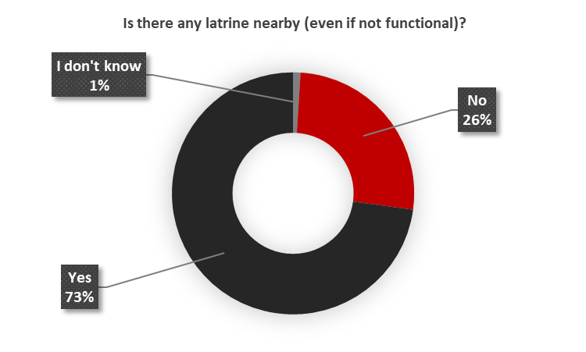

77% of HH said their latrines have a problem. A considerable number of HHs (14%) said “There is not enough facilities/too crowded” while 8% of HHs said “Latrines are unclean/unhygienic”. Some other various adduced problems with the latrines are:

* It is not safe (no door, no lock, etc)
* There is not enough facilities/too crowded
* Lack of privacy/no separation between men and women
* Structure is damaged (ex: due to storm)
* Cess pit is full
* Absence/insufficiency of water

38% of HHs use a Simple pit latrine, 15% use a ventilated improved pit (VIP) latrine, 11% use a shared block latrine. The remaining 36% of HHs make use of a combination of the aforementioned facilities with some still practicing open defection. On average, 3 HHs share a common shred block latrine. **13% of HHs practice open defecation in Rann.** 31% of HHs said there is no water and soap available to wash hands after using the latrine.

9% of HHs said women DO NOT feel safe to use the latrines at night.

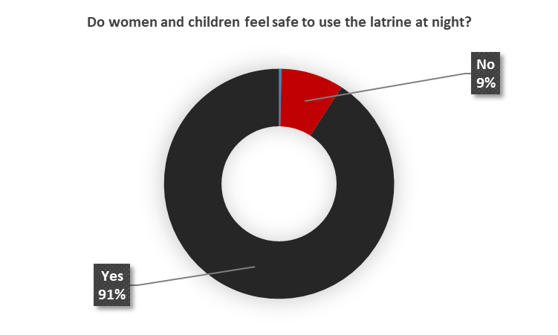

# Child Protection

The top 3 priority needs for children under 5 years old are:

1. Access to Food
2. Access to Water
3. Early childhood education

The top 3 priority needs for children over 5 years old are:

1. Access to Food
2. Education & schools
3. Cash money

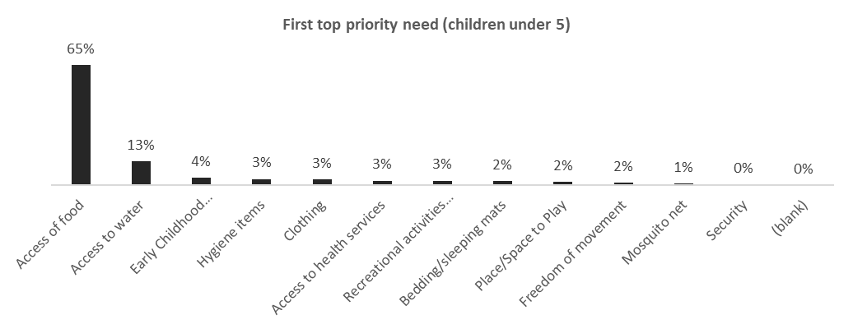

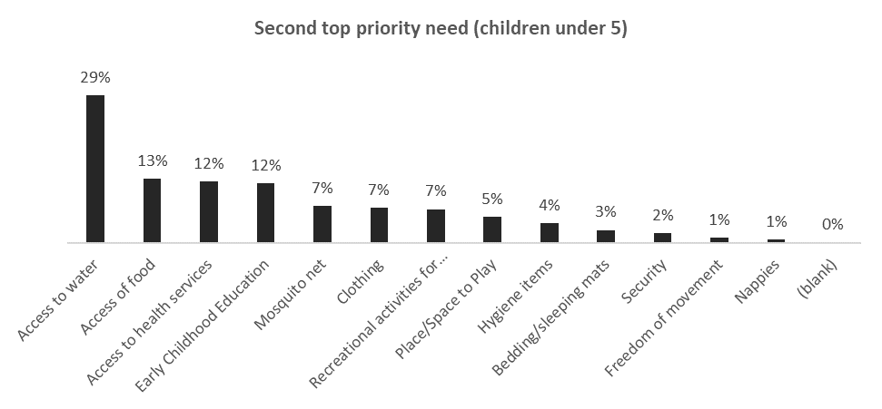

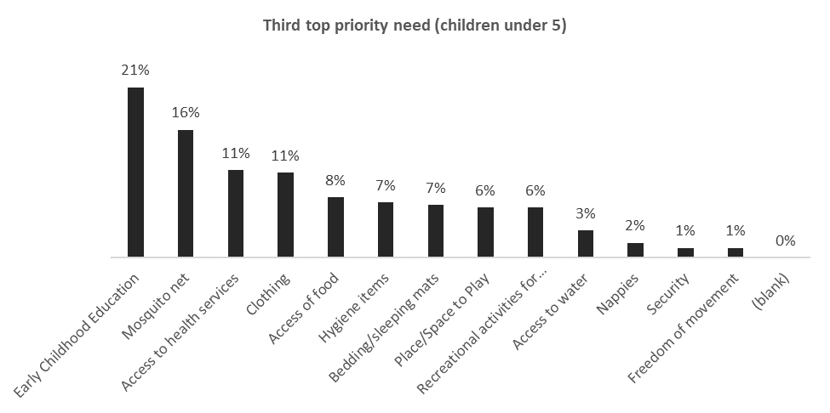

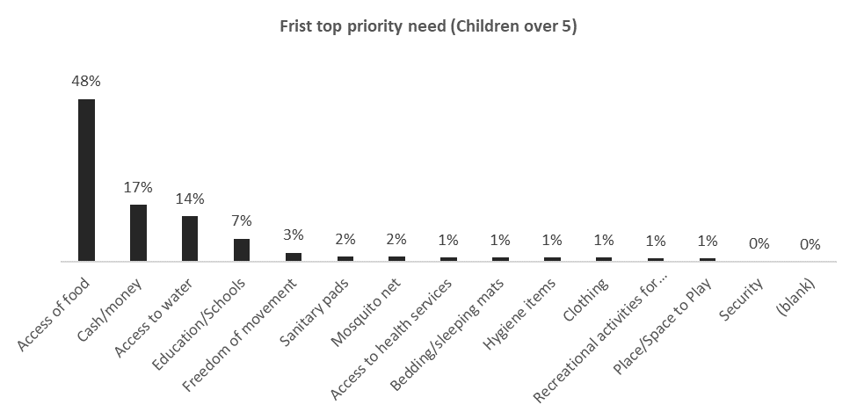

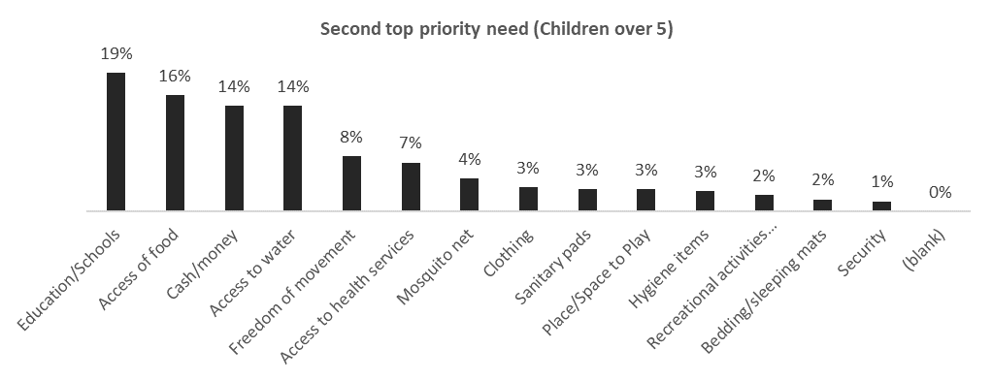

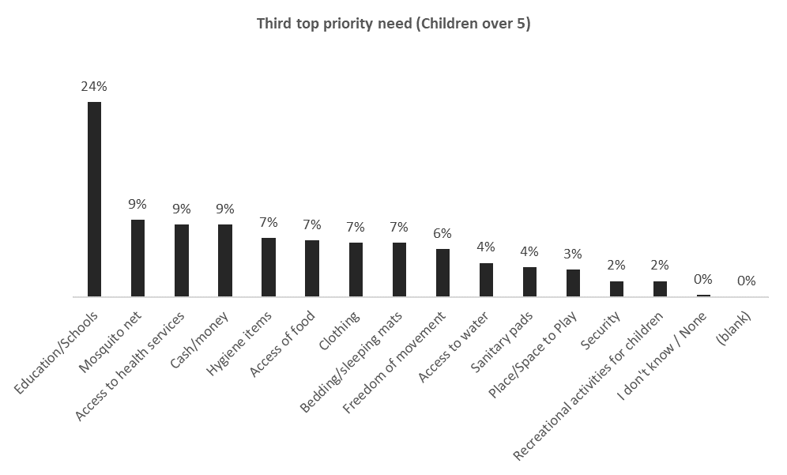

A ranking of the top risks children face within the community is presented in the chart below

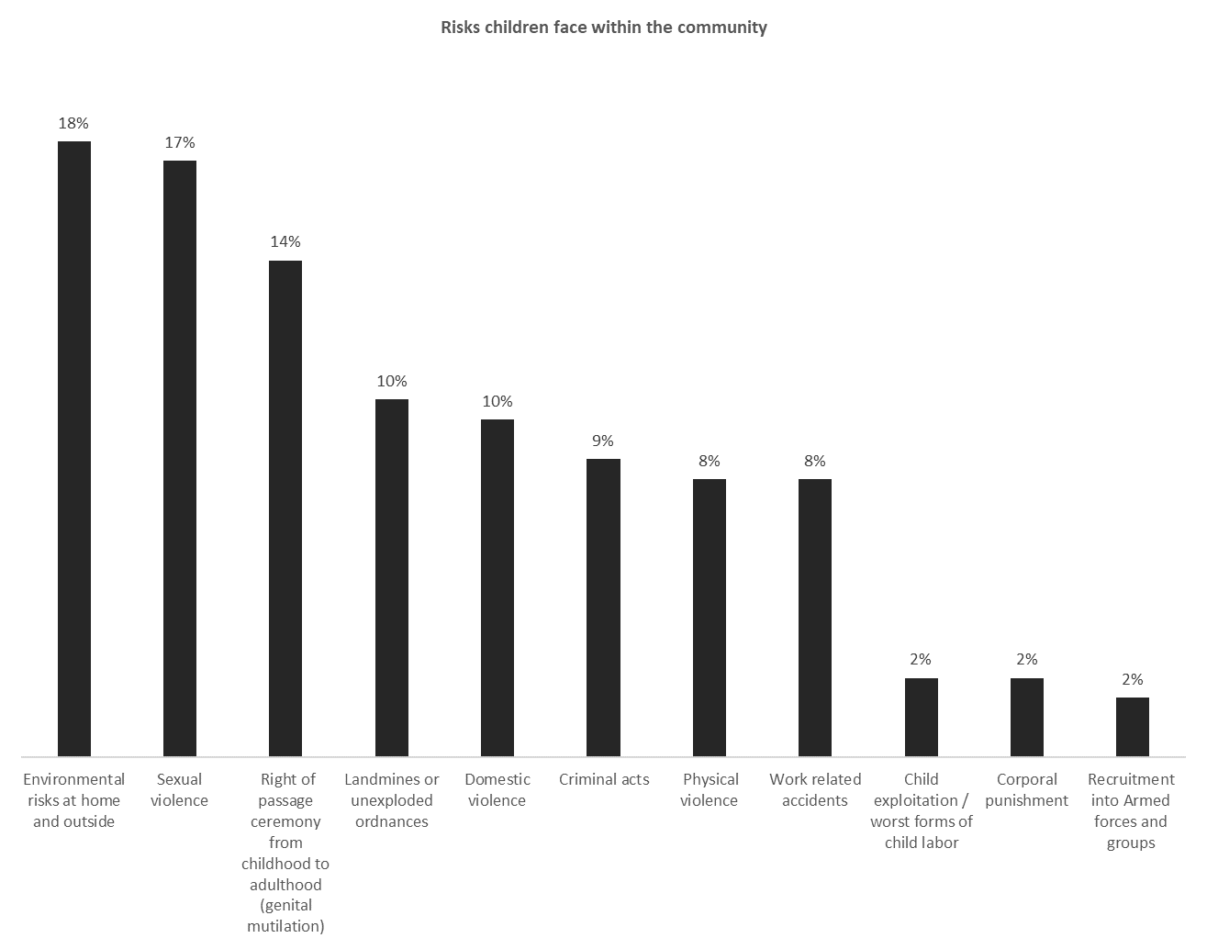

A ranking of the places where children are at higher risk in the community is presented in the chart below.

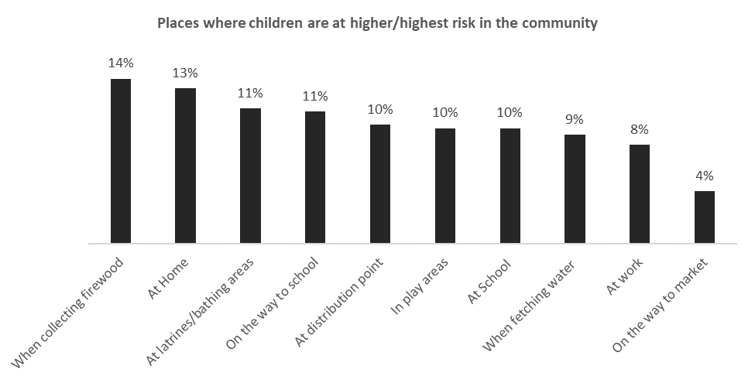

36% of HHs said there is no safe space where children can attend recreational activities in the community

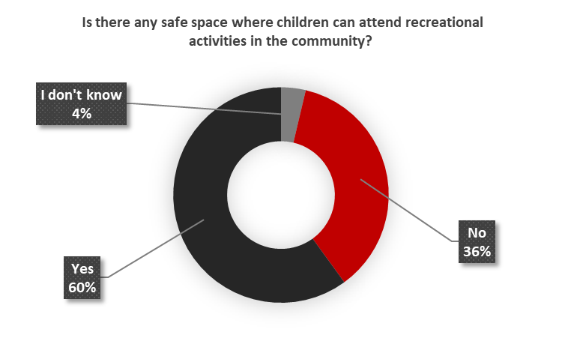

35% of HHs said they have heard about children being abducted/taken away by people from outside the community.

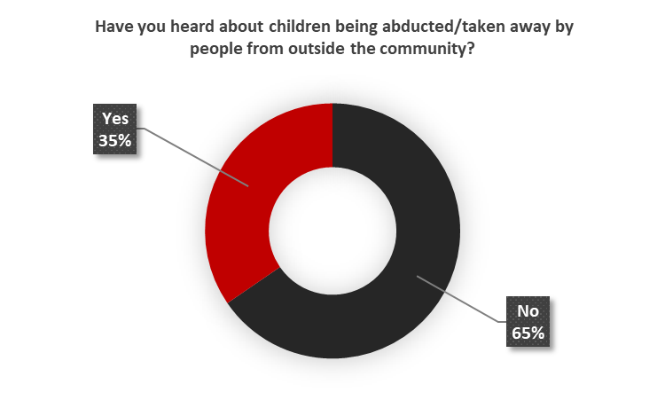

The most frequent reason (44%) for children being abducted in the camp is to enrolled in armed groups. This is seconded (16%) by girls being abducted to be married—usually at a minor age (below 18 years old).

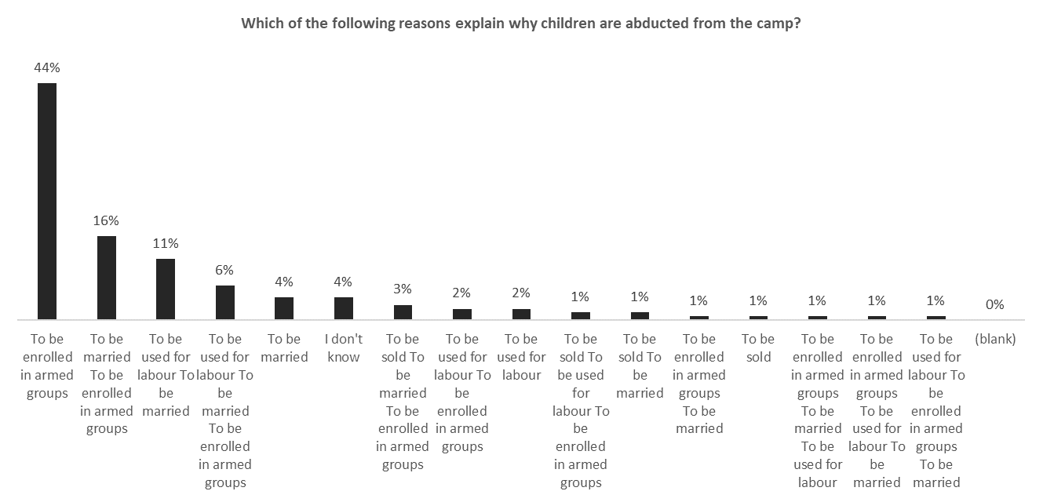

34% of HHs said they have seen/observed a change in the behavior of the children from their household in the last two months.

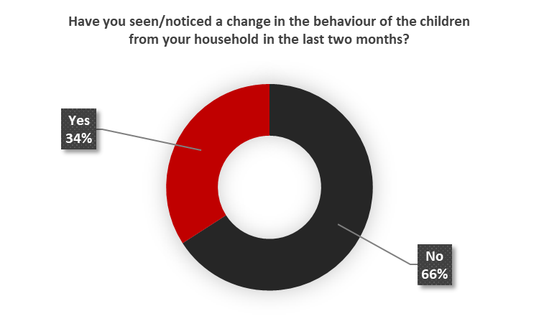

A ranking of the most frequent types of change in behavior in children observed by HHs in the last 2 months is presented in the chart below.

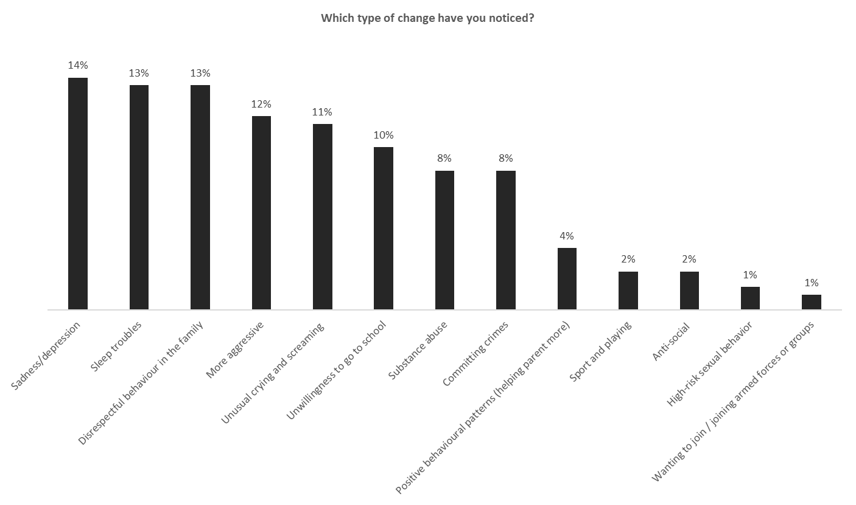

The top 3 reasons for these observed changes in the behavior of children are:

1. Fear of attacks from armed non-state groups
2. Loss of belongings
3. Separation from family/friends

A detailed ranking of these reasons is presented in the chart below.

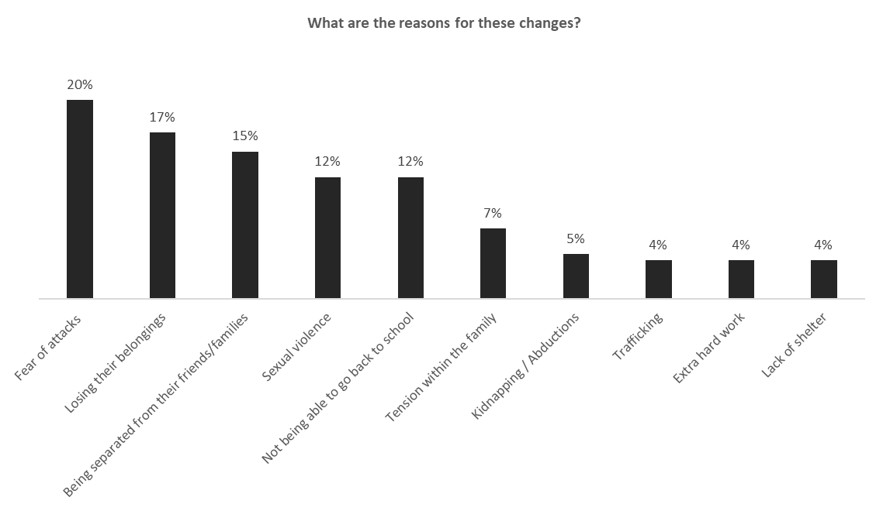

30% of HHs said there are children in their community who are committing acts of violence.

48% of HHs said there are some specific groups in the area that are being excluded from essential services and activities and these are elucidated in the bar chart below.

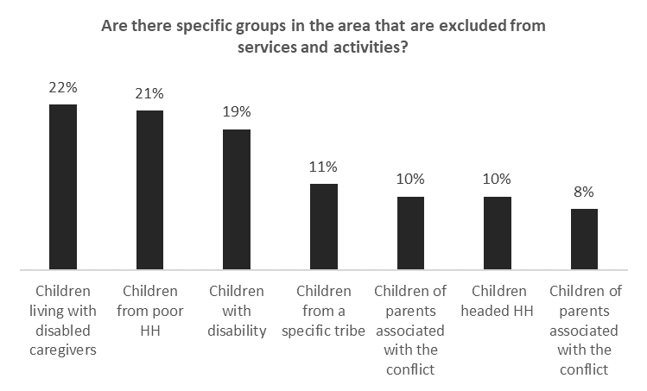

In Rann, **girls usually get married at an average age of 16 years old.**

42% of HHs have lost and are missing civil or legal documents.

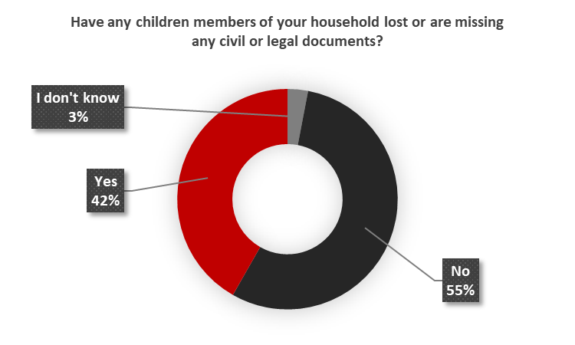

# Protection

The top 3 causes of stress for HHs are:

1. Lack of non-food items
2. Lost livelihood
3. Lack of shelter

A comprehensive break down of the first, second and third causes of stress is elucidated in the chart below.

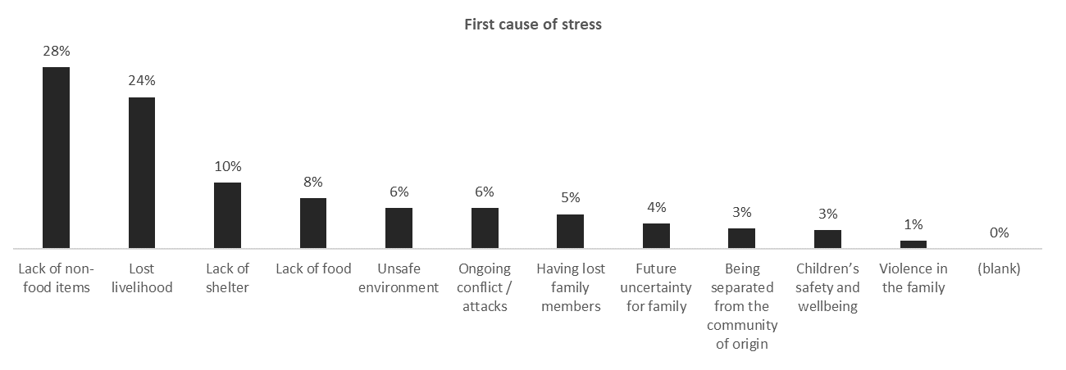

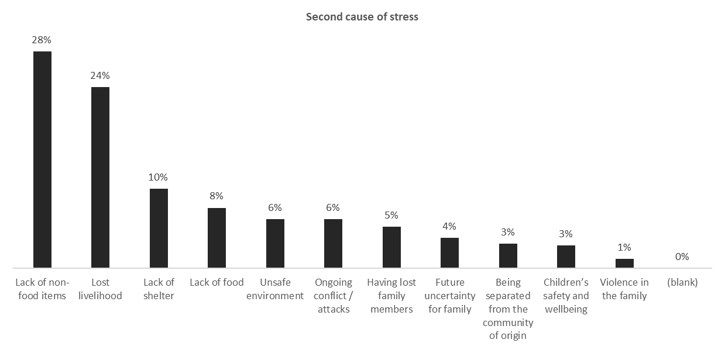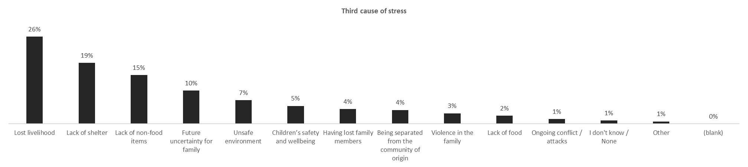

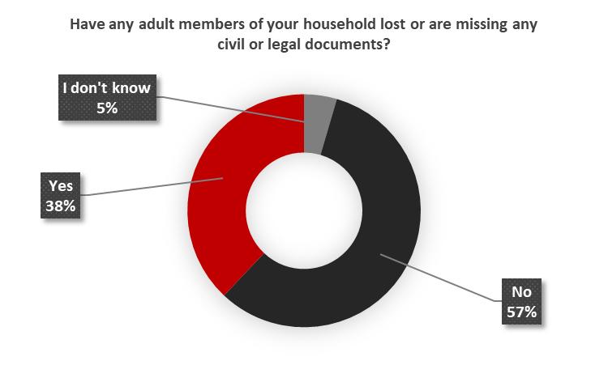

69% of respondents said they have experienced some sort of security concern and the top 3 frequently occurring security concerns revealed are:

1. Destruction of property (i.e arson) or theft/looting
2. Attacks or bombings
3. Forced recruitment by CJTF/vigilantes/AoGs

A comprehensive ranking of these concerns are presented in the chart below.

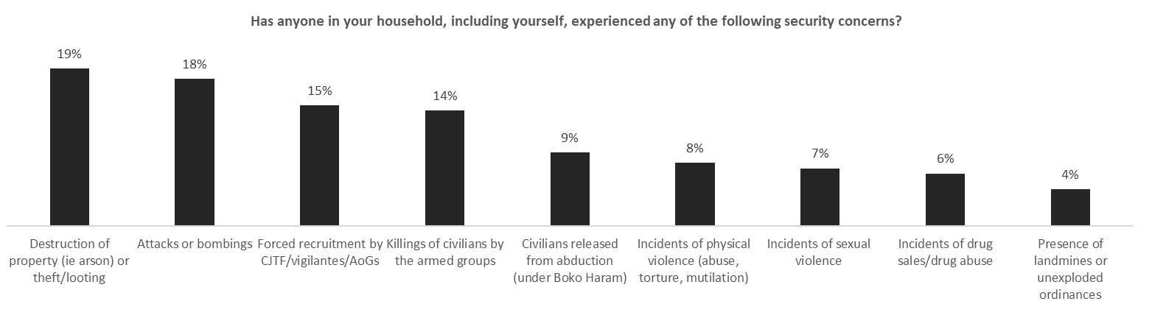

# Education

58% of HHs said their children (3-17 yrs) are NOT attending formal education.

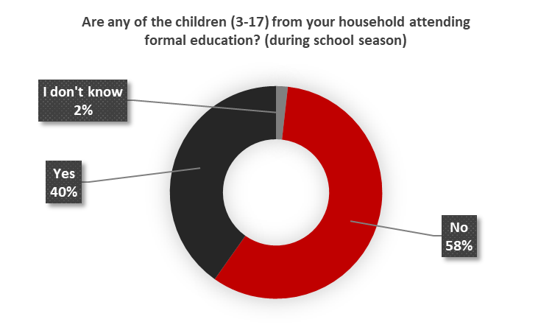

66% of HHs said their children (3-17 yrs) are NOT attending a non-formal learning center.

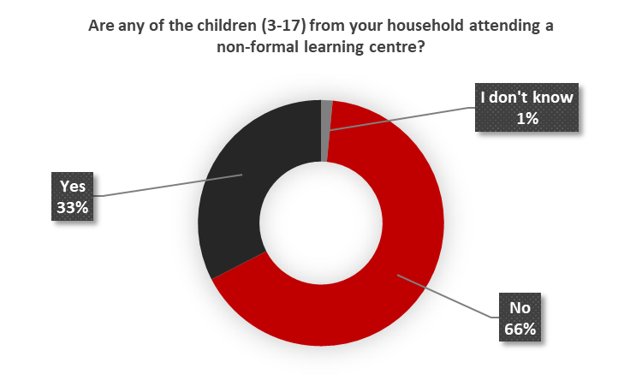

Children in Rann attend school an average of 4 days a week.

29% of HHs said their children (5-17) have completely dropped out of school.

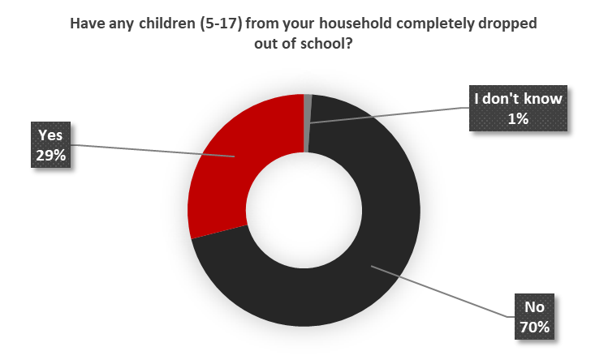

35% of HH said children in their HH have never attended school.

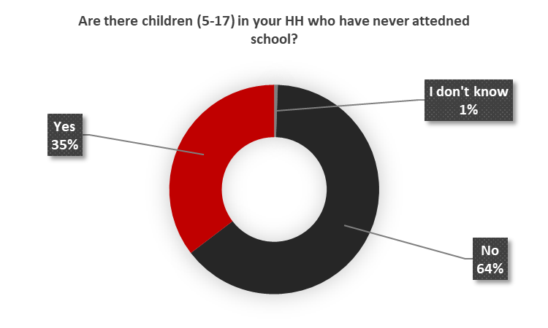

A breakdown of the reasons why their children have never attended school is presented in the chart below.

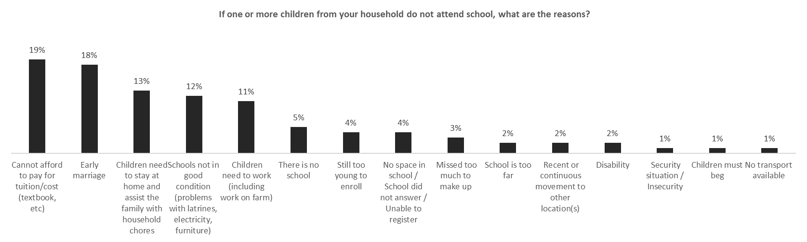

The most frequently occurring expense related to sending children to school is school uniform (30%) followed by books (15%) and bag (15%).

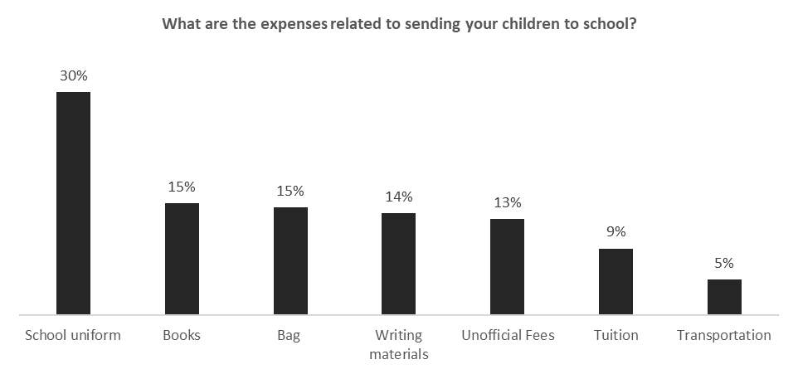

# FSL

The average monthly income of HHs in Rann is NGN 6657.

The average monthly expenditure of HHs in Rann is NGN 8384. This implies that HHs have a monthly cashflow deficit of NGN 1727.

The average number of adults contributing to the HH income in Rann is 1.

40% of HHs were engaged in Agriculture as the primary income source before the current situation. The remaining 60% of HHs were involved in a combination of agriculture and either fishery, livestock, selling of natural resources (charcoal, firewood etc), hunting, small business casual labour etc.

**39% OF HHs said they are not able to have income generation in their current situation**.

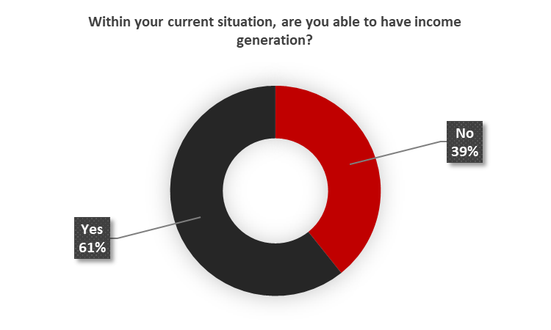

74% of HHs in Rann said they have outstanding debts.

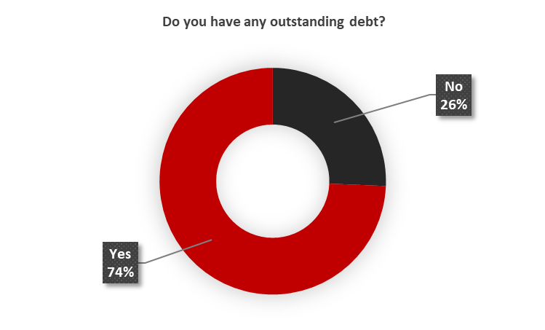

45% of HHs said they used the loans to buy food while the remaining 55% used the loan for a combination of food and either agricultural inputs, health expenses, clothing, education costs etc.

50% of HHs said their food is currently self-produced. 7% get their food from NGO distributions, the remaining 43% get their food from a combination of self-production and either food distribution, from the market or on credit.

13% of HHs said the nearest market is not accessible to them (87% said the nearest market is accessible to them).

78% of HHs said it takes them less than 15 minutes to walk to the nearest market while 19% said it takes them 16 to 30 minutes and 3% said it takes 31 minutes to an hour.

92% of HHs said there are sufficient varieties of food available in the nearest market.

The most frequently consumed food among HHs in Rann is cereals and tubers followed by pulses. A ranking of the most consumed foods in Rann is presented in the chart below.

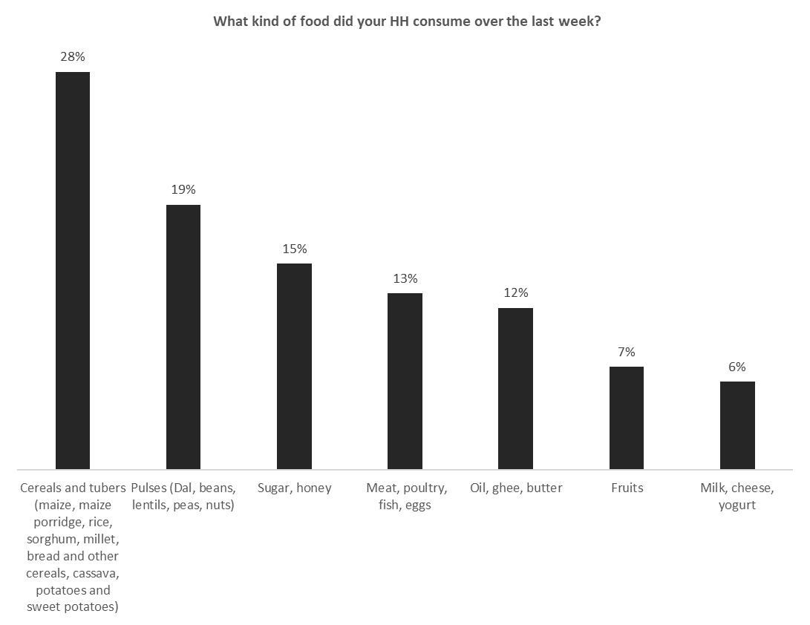

80% of HHs said these items are readily available in the local market.

HHs in Rann experience lack of food for an average of 4 days every month.

Children in Rann under 5 years old eat an average of 2 meals per day and other members of HHs also eat an average of 2 meals per day.

72% of HHs said they have received some food assistance since their displacement but 28% of HHs said they have not received any food assistance since displacement. 53% of HHs received food, while the remaining 47% received diverse combination of food and other items such as nutrition, kitchen utensils, cash for work, cash for training, cash for food and CMAM support. The chart below presents the actors that provided the aforementioned assistance.

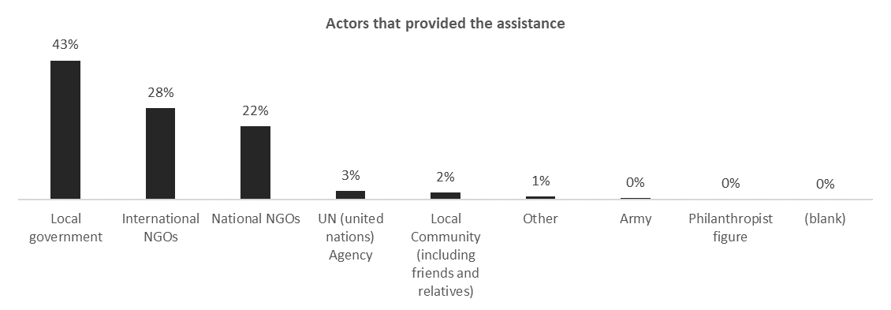

59% of HHs said they are not receiving any livelihood assistance since the crisis.

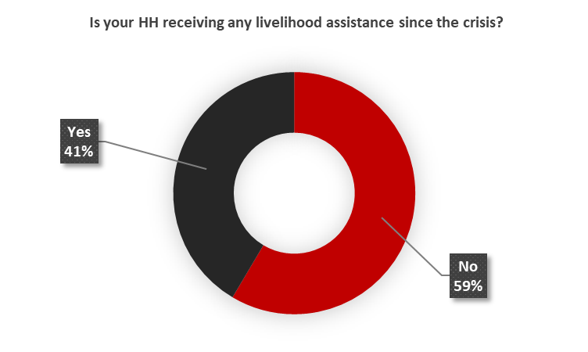

# Health

An average of 3 persons per HH sleep under a mosquito net in Rann.

40% of HHs visit an NGO hospital/clinic when somebody is sick in their HH. 17% visit a government hospital/clinic, 13% visit a government hospital/clinic or visit an NGO hospital/clinic. The remaining 30% either self-medicate, or indulge in traditional medical practices etc.

71% of the HHs that visit a health facility said they visit a Primary health care center/clinic. 7% visit a Government hospital or Primary health care center/clinic, 4% visit a Primary health care center/clinic or sometimes they do not use any health facility. 3% go to a Government hospital.

**22% of HHs said women DO NOT have access to antenatal care**.

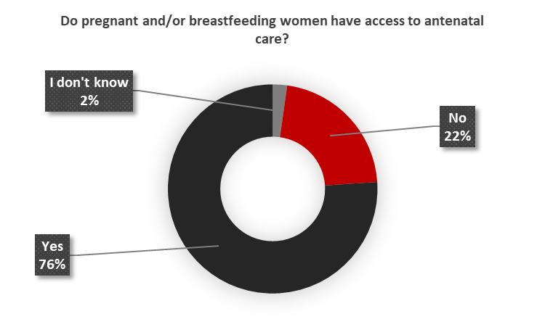

**40% of women in Rann said they give birth at home**.

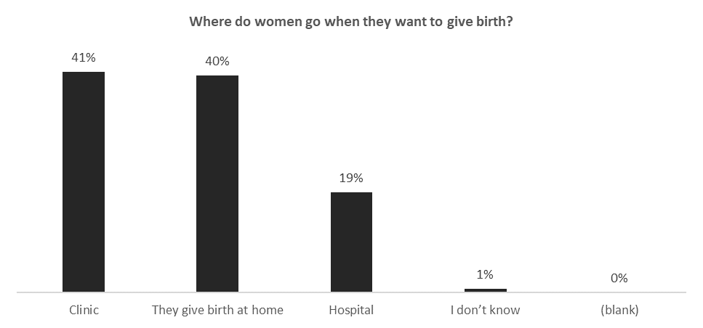

**32% of HHs said pregnant women in Rann do not deliver with the assistance of any healthcare professional.**

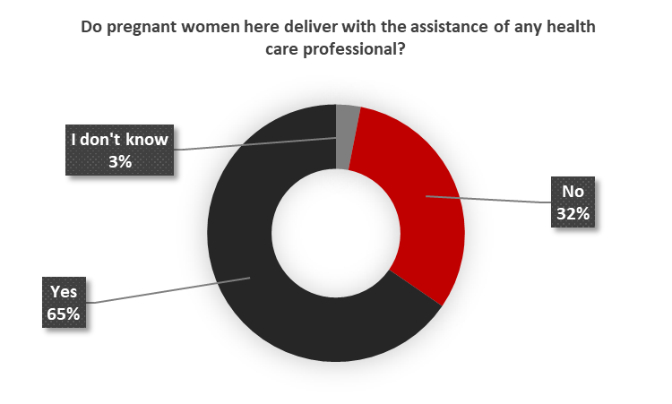

66% of women in Rann DO NOT know ways of preventing or delaying getting pregnant (delay or avoid getting pregnant).

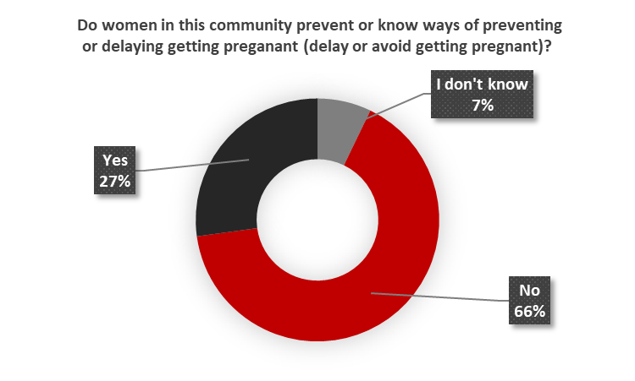

22% of HHs said in the most recent 2 weeks, a household member has suffered a health events. The average populations of individuals per HH who have suffered a health event in the most recent 2 weeks is presented below.

* Acute Respiratory Infections, cough and fever = 0
* Diarrhoea = 0
* Malnutrition = 0
* Fever = 1
* Skin disease = 0
* Cholera, accute watery diarrhoea (more than 3 time a day) = 0
* Injuries = 0
* Other issues = 0

24% of HHs said in the past four weeks a child under the age of 5 in their household suffered from diarrhea.

The average number of individuals per HH currently under the age of 5 who have been exclusively breastfed until the age of 6 months is 2.

42% of HHs said NO child or member of their household accessed a supplementary feeding program (infant, OPT, PLW) in the last 30 days.

30% of HHs said NO child in their HH has been screened (MUACed) in the past three months. 70% of HHs said a child was screened for MUAC and out of those HHs that had a child screened, 78% said the child was found to be in need of treatment.

**20% of HHs have a child under 5 who died in the last one month.** Of the families that lost a child under 5, an average of 1 child under 5 per HH died due to sickness in the last on month**.**

**16% of HHs said a pregnant woman has died in their HH in the last one month**. Of the families that lost a pregnant woman, an average of 1 pregnant woman per HH died due to accident.

11% of HHs said a breastfeeding mother has died in their HH in the last one month. Of the families that lost a breastfeeding woman, an average of 1 breastfeeding woman per HH as died due to accident.

11% of HHs said someone else has died in their HH in the last one month. Of the families that lost someone else, an average of 1 person per HH died due to accident, an average of 4 persons per HH died due to sickness.

**61% OF HHs said their women DO NOT see health workers before and after delivery.**

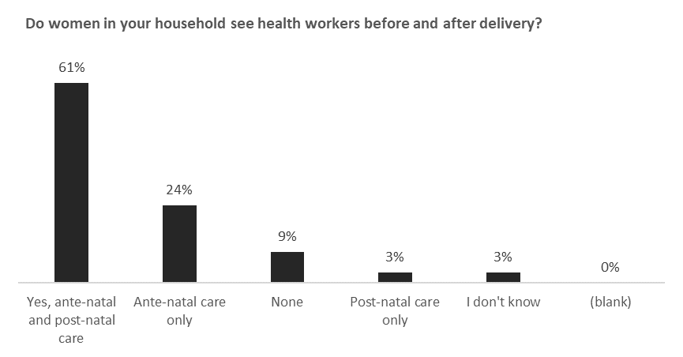

An average of 1 child per HH has been vaccinated in Rann.

# Humanitarian Service needs

The top 3 service needs of HHs are:

1. Food assistance
2. Education support
3. Health support

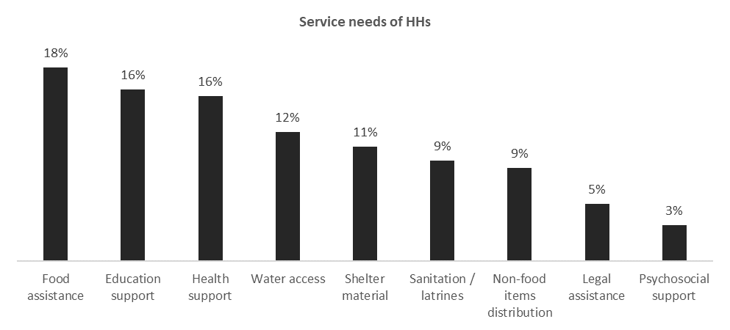

20% of HHs said these needed services are not accessible to their HH.

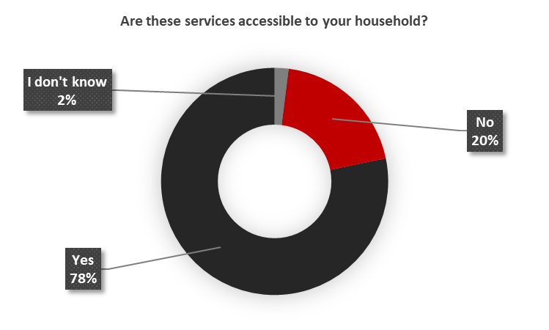

# Summary and Conclusion

The average population of individuals per HH in Rann is 8. It is important to note that 70% of HHs in Rann are IDPs while 15% are returnees and 14% are non-displaced/host community HHs. In Rann, there is a protection concern occasioned by the vulnerable 24% of HHs that are women headed households. Futhermore, 55% of HHs in Rann are currently hosting other people who are not family members and sharing their resources with them. These HHs are hosting an average of 3 such persons per HH. There is an average of 1 unaccompanied child per HH.

**Shelter**

* 35% of shelters in which HHs reside are in a poor state (not meeting all the needs and definitely needs improvement).

**WASH**

**Water Access**

* 47% of HHs in Rann spend more than 30 mins up to 2 hours at the water points on the waiting queues before they fetch water.
* HHs have an average of 3 water containers per HH for water collection.
* The average water collected per person per day is 15 liters
* 28% of HHs (approximately 3500 HHs) in Rann do not have a water storage container.
* The average water storage capacity per person per day per HH is 9 liters.
* 52% of HHs (approximately 6500 HHs) have less than 10 liters per person per day water storage capacity

**Access to Sanitation Facilities**

* 26% of HHs do not have a latrine nearby. This implies that 26% of HHs DO NOT have access to a latrine facility.
* 77% of HH said their latrines have a problem.
* 13% of HHs practice open defecation in Rann
* 31% of HHs said there is no water and soap available to wash hands after using the latrine.
* 9% of HHs said women DO NOT feel safe to use the latrines at night.

**Hygiene Promotion**

* 25% of HHs (approximately 3,125 HHs) did not receive any NFI kits during displacement
* 18% of HHs(approximately 2,250 HHs) DO NOT treat their water before drinking.
* 19% of HHs (approximately 2,375 HHs) do not have soap.
* 7% of HHs know less than 3 critical times they should wash their hands in a day.
* 7% of HHs DO NOT clean their water containers**.**
* 39% of HHs in Rann (approximately 4,875 HHs) DO NOT have a hand washing device in their HH.
* 30% of HHs (approximately 3,750 HHs) have not attended any hygiene promotion session in the last 1 month.

**Child Protection**

The top 3 priority needs for children under 5 years old are:

1. Access to Food
2. Access to Water
3. Early childhood education

The top 3 priority needs for children over 5 years old are:

1. Access to Food
2. Education & schools
3. Cash money

* 36% of HHs said there is no safe space where children can attend recreational activities in the community.
* 35% of HHs said they have heard about children being abducted/taken away by people from outside the community. The most frequent reason (44%) for children being abducted in the camp is to enrolled in armed groups. This is seconded (16%) by girls being abducted to be married—usually at a minor age (below 18 years old).
* 48% of HHs said there are some specific groups in the area that are being excluded from essential services.
* In Rann, girls usually get married at an average age of 16 years old.
* 42% of HHs have lost and are missing civil or legal documents.

**Education**

* 58% of HHs said their children (3-17 yrs) are NOT attending formal education.
* 66% of HHs said their children (3-17 yrs) are NOT attending a non-formal learning center.
* 29% of HHs said their children (5-17) have completely dropped out of school.
* 35% of HH said children in their HH have never attended school.
* The most frequently occurring expense related to sending children to school is school uniform (30%) followed by books (15%) and bag (15%).

**FSL**

* 39% OF HHs said they are not able to have income generation in their current situation.
* 74% of HHs in Rann said they have outstanding debts.
* HHs in Rann experience lack of food for an average of 4 days every month.
* 59% of HHs said they are not receiving any livelihood assistance since the crisis.

**Health**

* 30% of HHs either self-medicate, or indulge in traditional medical practices etc., when somebody is sick
* 22% of HHs said women DO NOT have access to antenatal care.
* 40% of women in Rann said they give birth at home.
* 32% of HHs said pregnant women in Rann do not deliver with the assistance of any healthcare professional.
* 66% of women in Rann DO NOT know ways of preventing or delaying getting pregnant (delay or avoid getting pregnant).
* 20% of HHs have a child under 5 who died in the last one month. Of the families that lost a child under 5, an average of 1 child under 5 per HH died due to sickness in the last on month.
* 16% of HHs said a pregnant woman has died in their HH in the last one month. Of the families that lost a pregnant woman, an average of 1 pregnant woman per HH died due to accident.
* 61% OF HHs said their women DO NOT see health workers before and after delivery.

**Humanitarian Service needs**

The top 3 service needs of HHs are:

1. **Food assistance**
2. **Education support**
3. **Health support**

# APPENDIX

1. **Survey Questionnaire: **

1. Quinn, Ben; Akinwotu, Emmanuel (17 January 2017). [*"Nigeria air strike: dozens dead as camp for internally displaced people hit by mistake"*](https://www.theguardian.com/world/2017/jan/17/nigeria-military-jet-mistakenly-bombs-displaced-families-camp-boko-haram). The Guardian*. Retrieved 18 January 2017*
2. [*"Islamic State insurgents overrun northeast Nigerian town: security..."*](https://www.reuters.com/article/us-nigeria-security-insurgency-idUSKCN1P82I1) 14 January 2019*. Retrieved 21 January 2019* – via www.Reuters.com.
3. Paul Carsten (1 February 2019). [*"After Nigerian army abandoned town, Boko Haram slaughtered at least 60"*](https://www.reuters.com/article/us-nigeria-security-insurgency/after-nigerian-army-abandoned-town-boko-haram-slaughtered-at-least-60-idUSKCN1PQ55I). Reuters*. Retrieved 24 February 2019*.
4. Quinn, Ben; Akinwotu, Emmanuel (17 January 2017). [*"Nigeria air strike: dozens dead as camp for internally displaced people hit by mistake"*](https://www.theguardian.com/world/2017/jan/17/nigeria-military-jet-mistakenly-bombs-displaced-families-camp-boko-haram). The Guardian*. Retrieved 18 January 2017*
5. [*"Islamic State insurgents overrun northeast Nigerian town: security..."*](https://www.reuters.com/article/us-nigeria-security-insurgency-idUSKCN1P82I1) 14 January 2019*. Retrieved 21 January 2019* – via www.Reuters.com.
6. Paul Carsten (1 February 2019). [*"After Nigerian army abandoned town, Boko Haram slaughtered at least 60"*](https://www.reuters.com/article/us-nigeria-security-insurgency/after-nigerian-army-abandoned-town-boko-haram-slaughtered-at-least-60-idUSKCN1PQ55I). Reuters*. Retrieved 24 February 2019*.
7. From an estimated population of 75,000 individuals (Average population per HH is 6 based on TdH 2018 estimates)